**TITLE**

SUBTITLE

**COMSATS University Islamabad**

Sahiwal Campus

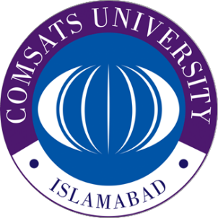

**Usama Sarwar**

FA17-BS(CS)-090-B

**Instructor**

Course

November 03, 2019

Table of Contents

**No table of contents entries found.**

List of Figures

TITLE

SUBTITLE